**Computer Security – Project 2**

Due Date: 8/2/19

Shyam Rajendren

**Task 1: become a Certificate Authority (CA)**

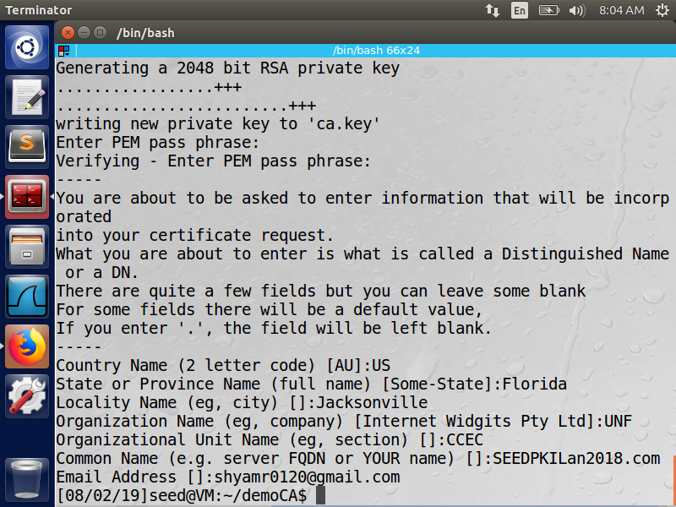

**Observation:**

Public key certificate (ca.crt) and CA’s private key (ca.key) is generated using the openssl and RSA command.

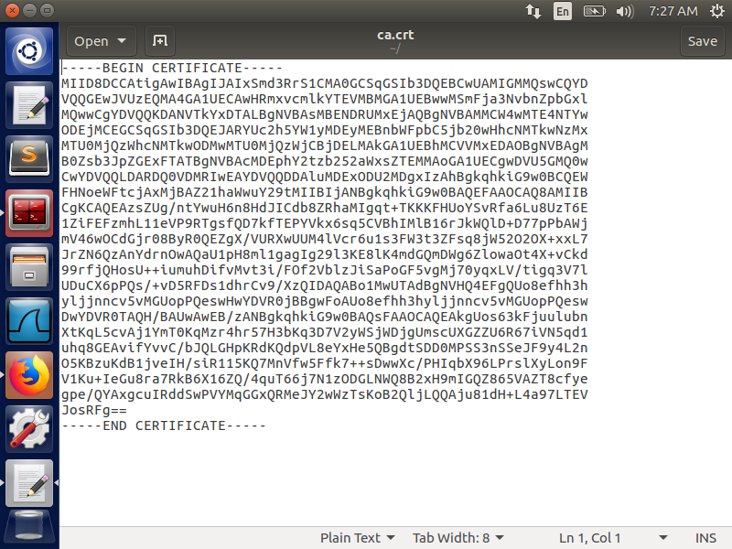

**Observation:**

The public key certificate generated using openssl and RSA.

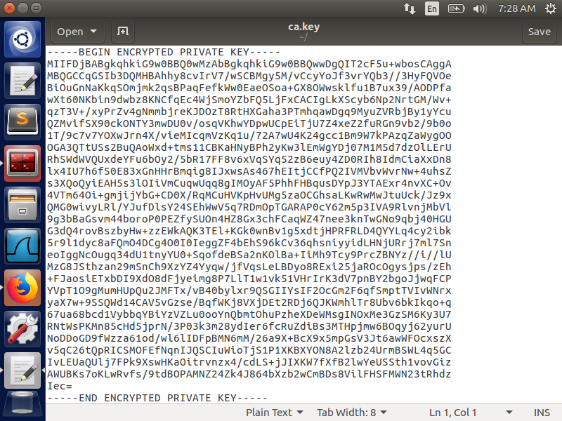

**Observation:**

The CA’s private key generated using openssl and RSA.

**Task 2: Create a certificate for SEEDPKILab2018.com**

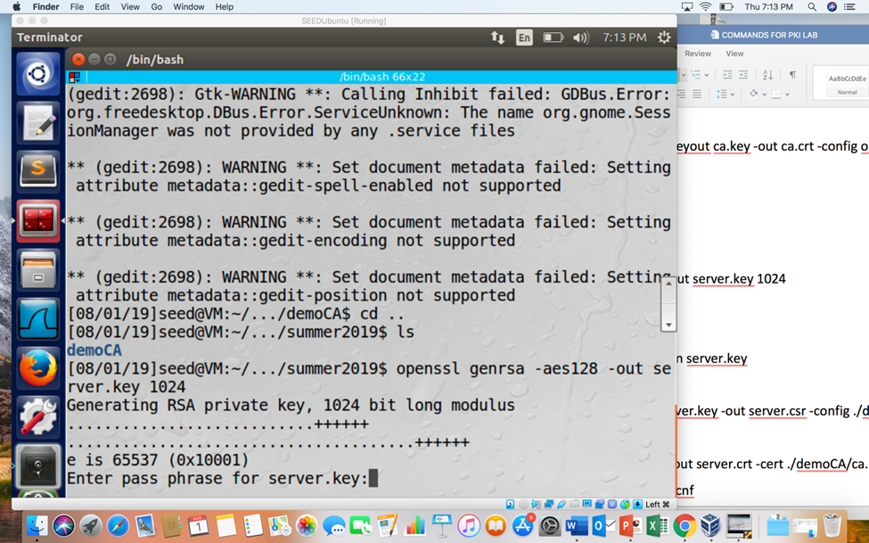

**Observation:**

A public/private RSA key pair is generated using openssl and it is stored in server.key.

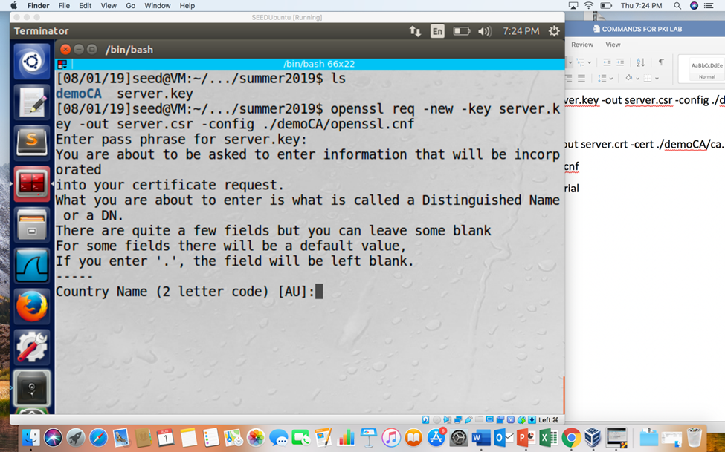

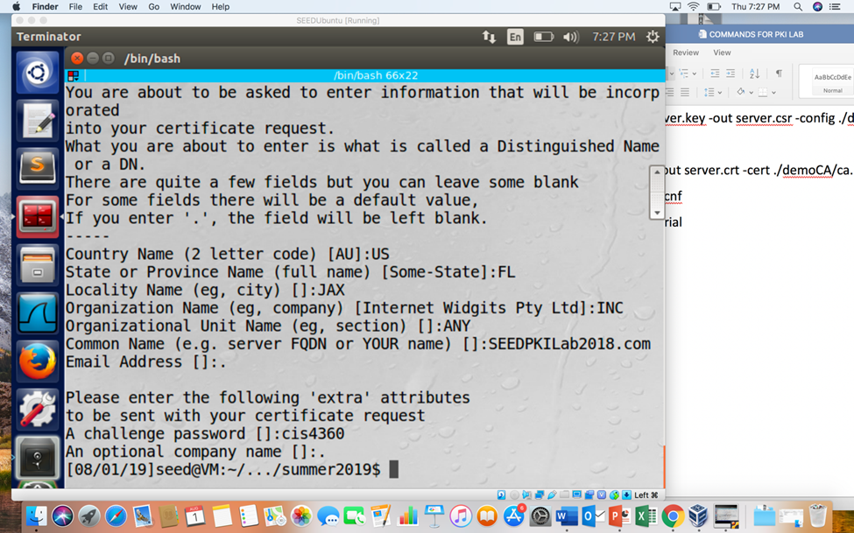

**Observation:**

The Certificate Signing Request (CSR) is generated using server.key which is used to generate a certificate for the key.

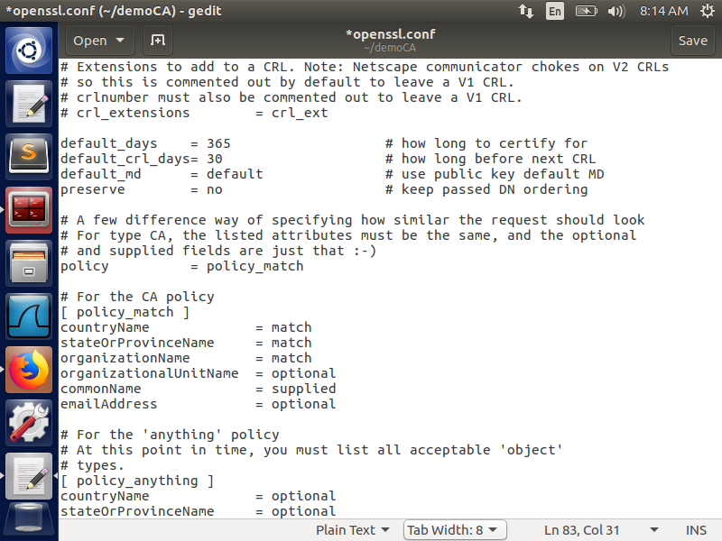

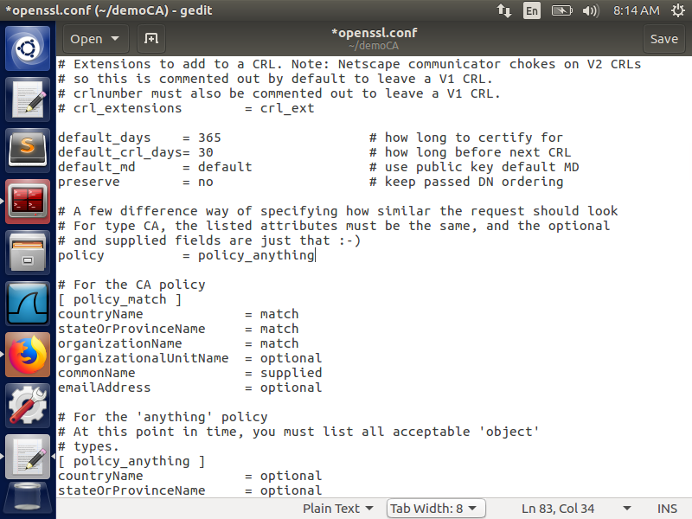

**Observation:**

Changing the policy from policy_match to policy_anything.

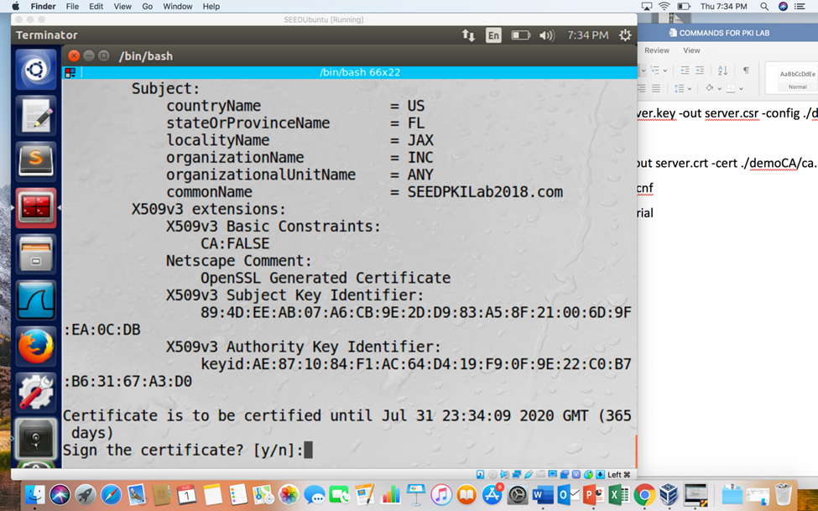

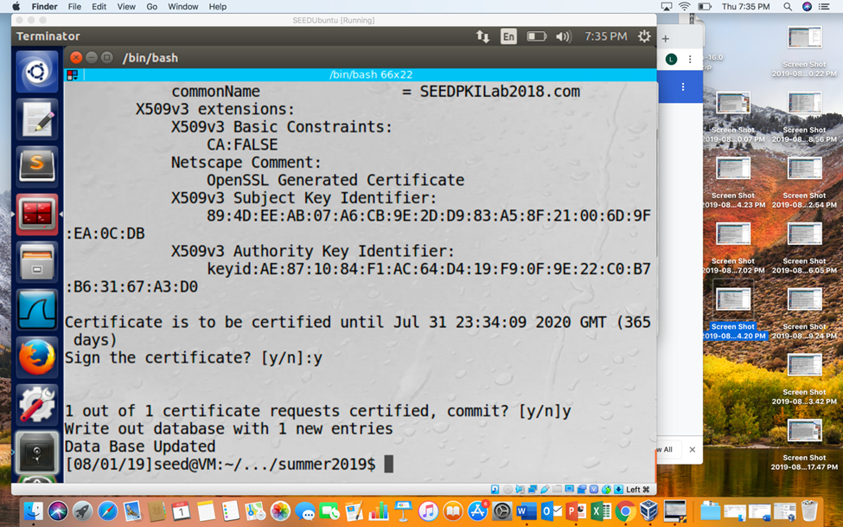

**Observation:**

The CSR file is sent to the CA and it is signed using cs.crt and ca.key to generate server.crt certificate for SEEDPKILab2018.com

**Task 3: Deploying Certificate in an HTTPS Web Server**

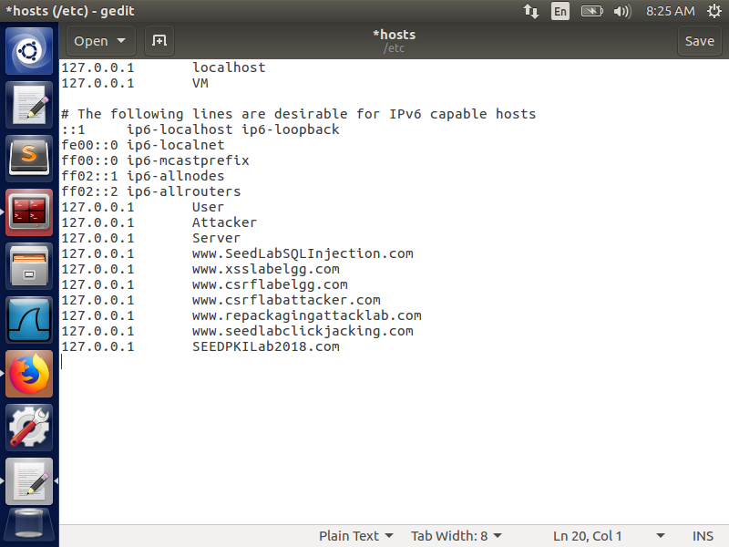

**Observation:**

SEEDPKILab2018.com is mapped to the localhost so that it can be used as a domain name.

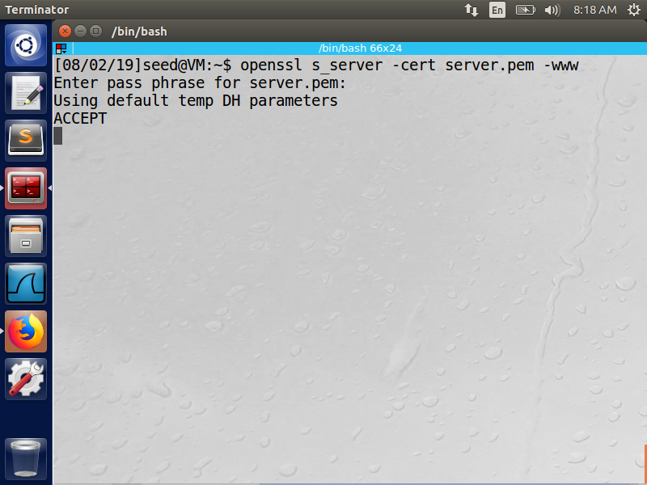

**Observation:**

After the server is mapped to local host it can be launched using server.pem which is formed by joining server.key and server.crt

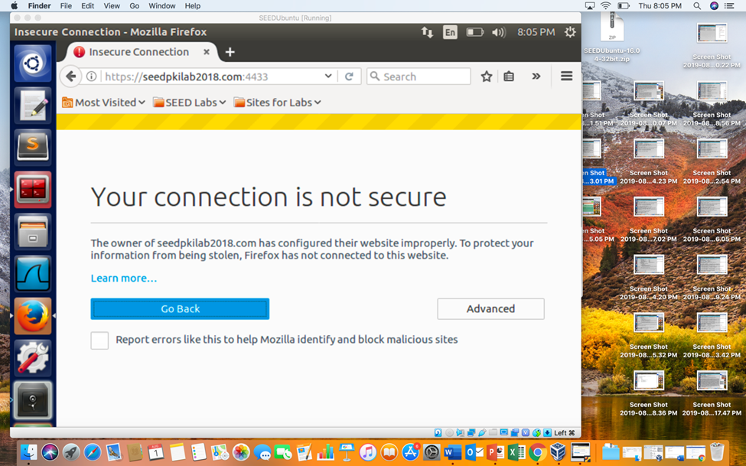

**Observation:**

The access to the server using the URL is not trusted by the web browser since the certificate is not assigned by any trusted company.

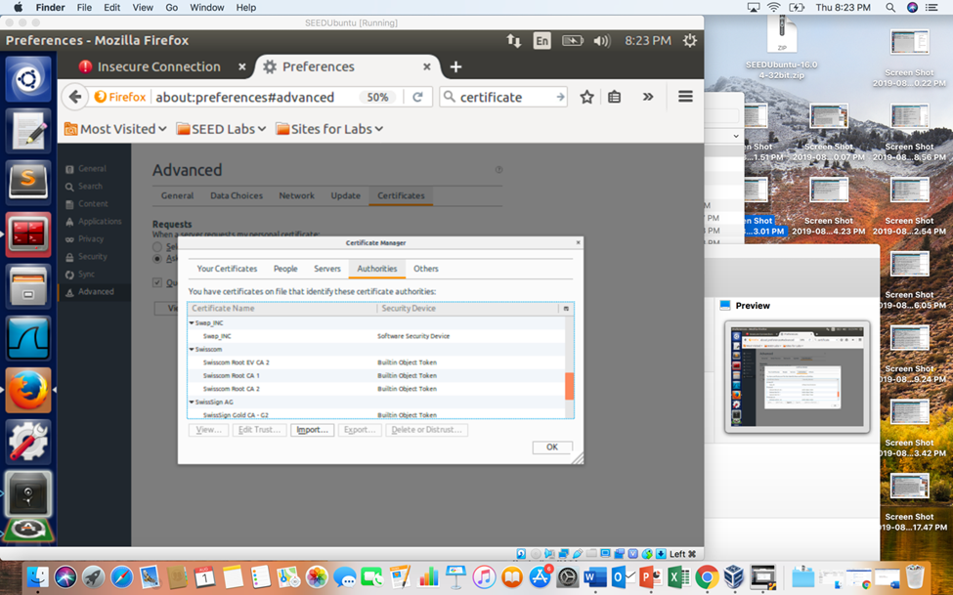

**Observation:**

ca.crt is manually added into the web browser.

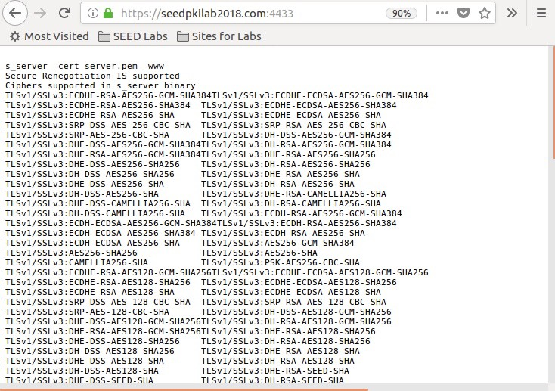

**Observation:**

The URL is now trusted since it is certified by ca.crt

**Task 4: Deploying Certificate in an Apache-Based HTTPS Website**

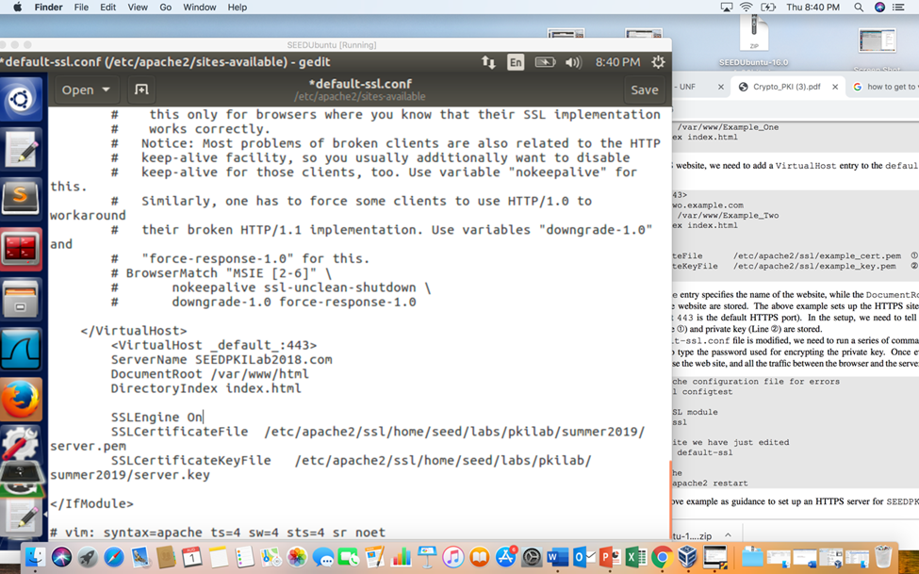

**Observation:**

We add a VirtualHost entry for SEEDPKILab2018.com in default-ssl.conf.

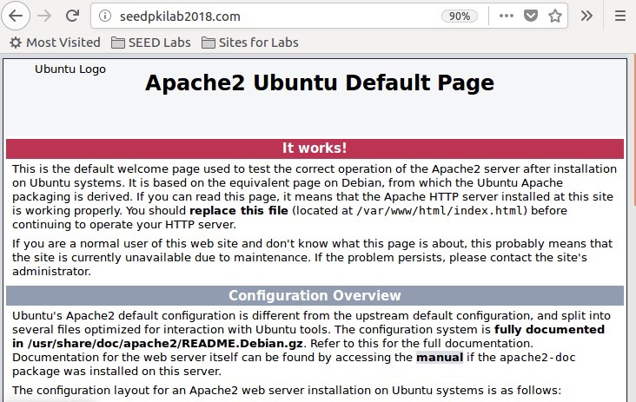

**Observation:**

The default apache website is shown for SEEDPKILab2018.com.

**Task 5: Launching a Man-In-The-Middle Attack**

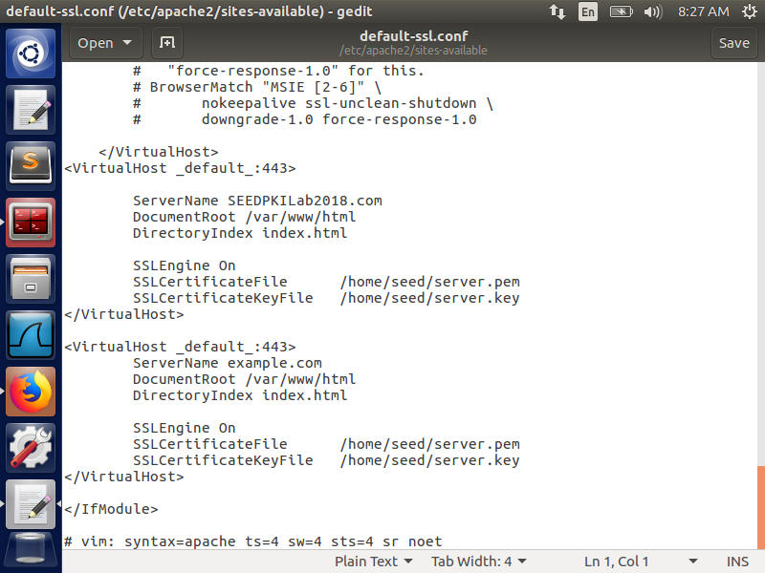

**Observation:**

We add a VirtualHost entry for example.com in default-ssl.conf.

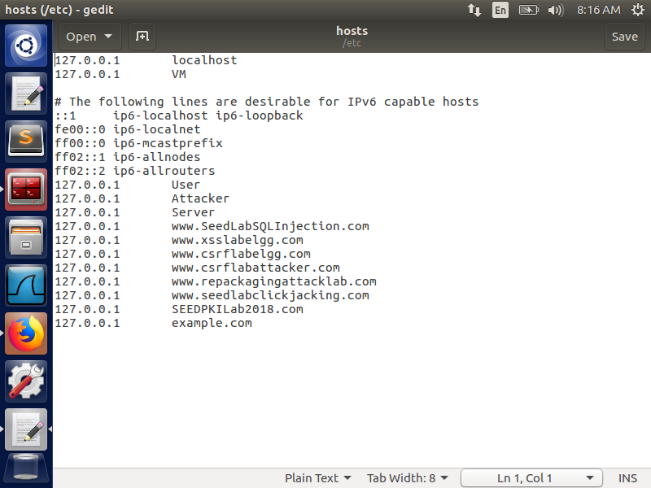

**Observation:**

We add example.com to the list of hosts and have it share the same IP Address as SEEDPKILab2018.com.

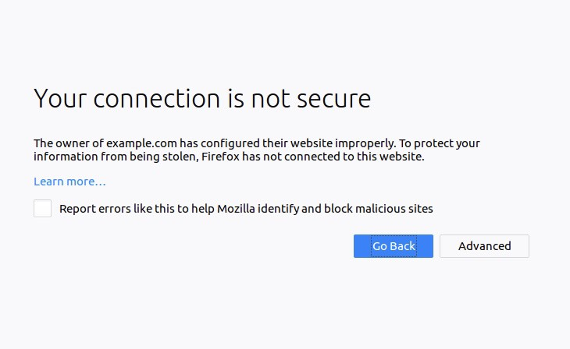

**Observation:**

The redirection fails as the common name does not match the common name that is specified in the authorized certificate.